**Lab Report Name: Installation of LINUX**

LINUX:

Linux is the foundation of thousands of open source operating systems designed to replace Windows and Mac OS. It is free to download and install on any computer. Because it is open source, there are a variety of different versions, or distributions, available developed by different groups. Follow this guide for basic instructions on how to install any version of Linux, as well as specific instructions for some of the most popular ones.

**1. Download the Linux distribution of our choice.** If we are new to Linux, consider trying a lightweight and easy to use distribution, such as Ubuntu or Linux Mint. Linux distributions (known as "distros") are typically available for free to download in ISO format. You can find the ISO for the distribution of your choice at the distribution’s website. This format needs to be burned to a CD or USB stick before you can use it to install Linux. This will create a Live CD or Live USB.

* A Live CD or Live USB is a disk that you can boot into, and often contains a preview version of the operating system that can be run directly from the CD or USB stick.
* Install an image burning program, or use your system’s built-in burning tool if we are using Windows 7, 8, or Mac OS X. Pen Drive Linux and UNetBootin are two popular tools for burning ISO files to USB sticks.

**2. Boot into the Live CD or Live USB.** Most computers are set to boot into the hard drive first, which means you will need to change some settings to boot from your newly-burned CD or USB. Start by rebooting the computer.

* Once the computer reboots, press the key used to enter the boot menu. The key for your system will be displayed on the same screen as the manufacturer’s logo. Typical keys include F12, F2, or Del.
  + For Windows 8 users, hold the Shift key and click restart. This will load the Advanced Startup Options, where you can boot from CD.
  + For Windows 10 users, go to advanced boot in settings and click "Restart Now."
  + If our computer doesn't give you direct access to the boot menu from the manufacturer's splash screen, it's most likely hidden in the BIOS menu. You can access the BIOS menu in the same way that you would get to the boot menu. At the manufacturer splash screen, the key should be listed in one of the bottom corners.
* Once we are in the boot menu, select your live CD or USB. Once you’ve changed the settings, save and exit the BIOS setup or boot menu. our computer will continue with the boot process.

**3. Try out the Linux distribution before installing.** Most Live CDs and USBs can launch a "live environment", giving you the ability to test it out before making the switch. You won’t be able to create files, but you can navigate around the interface and decide if it’s right for you.

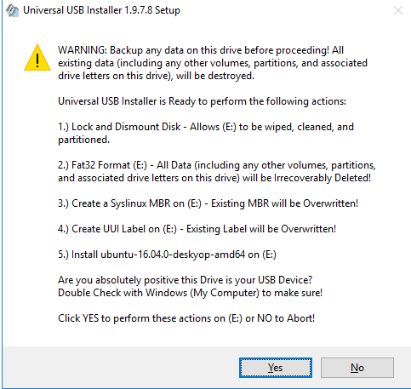

**5. Start the installation process.** If we are trying out the distro, you can launch the installation from the application on the desktop. If you decided not to try out the distribution, you can start the installation from the boot menu.

* We will be asked to configure some basic options, such as language, keyboard layout, and timezone.

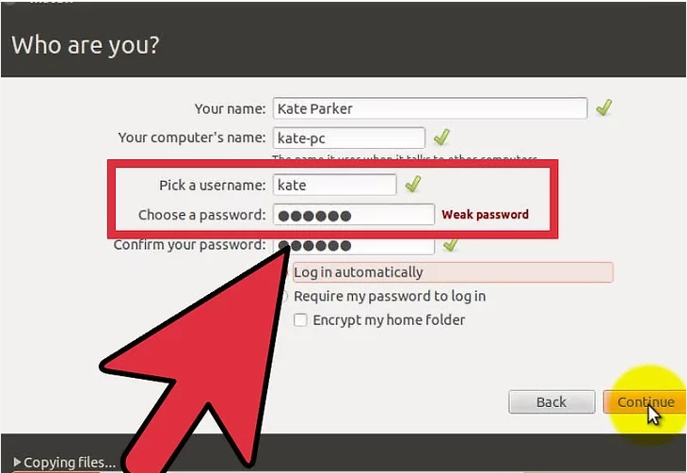

**7. Set up the partition.** Linux needs to be installed on a separate partition from any other operating systems on your computer if you intend dual booting Linux with another OS. A partition is a portion of the hard drive that is formatted specifically for that operating system. We can skip this step if we don't plan on dual booting.

* Distros such as Ubuntu will set a recommended partition automatically. You can then adjust this manually yourself. Most Linux installations require at least 20 GB, so be sure to set aside enough room for both the Linux operating system and any other programs you may install and files you may create.
* If the installation process does not give us automatic partitions, make sure that the partition you create is formatted as Ext4. If the copy of Linux you are installing is the only operating system on the computer, we will most likely have to manually set your partition size.

**8. Boot into Linux.** Once the installation is finished, your computer will reboot. You will see a new screen when your computer boots up called “GNU GRUB”. This is a boot loader that handles Linux installations. Pick your new Linux distro from the list. This screen may not show up if you only have one operating system on your computer. If this screen isn't being presented to you automatically, then you can get it back by hitting shift right after the manufacturer splash screen.

* If we install multiple distros on our computer, they will all be listed here.

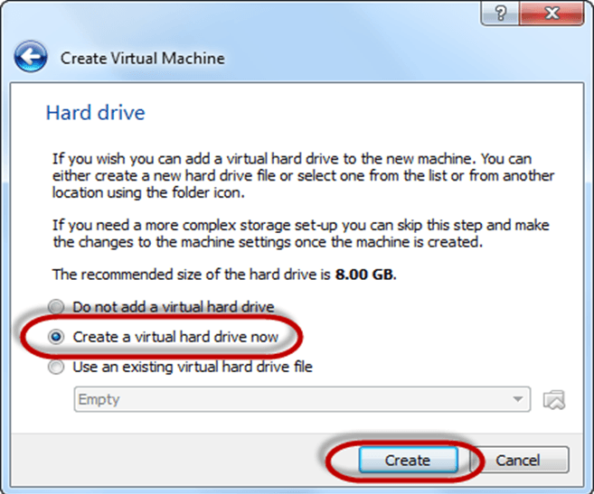

9. **Start using Linux.** Once our installation is complete and we’ve verified that our hardware is working, we are ready to start using Linux. Most distros come with several popular programs installed, and we can download many more from their respective file repositories.